**Course Name: CMPE 272 Enterprise Software Platforms**

**Team Name: Packers**

**Team Members: Purvaben Patel, Amrapali Sarkar, Gagandeep Singh,**

**Dinesh Yalla, Shaily Khare**

**KARAF ASSIGNMENT**

**Abstract:**

In this assignment, a client application is built which implements 10 Twitter REST APIs. Authentication in Twitter is performed using oauth. We have Nodejs at our server side in which we give REST API calls. The REST API return the data in JSON format which is parsed in Angular JS and is displayed as User Interface. The User Interface is built on Angular JS where data handling is done through node.js and Unit testing is performed in Chai Mocha. UML Diagrams and screenshots are provided for proper understanding of the application.

**Detailed Steps:**

1. **KARAF** 
   1. Download **apache-karaf-4.0.6** from <https://karaf.apache.org/download.html> and extract that .zip file.
   2. For Karaf welcome screen :

* Open Command Prompt.
* Go to the location where your Karaf folder is located.
* Run : bin\karaf.bat

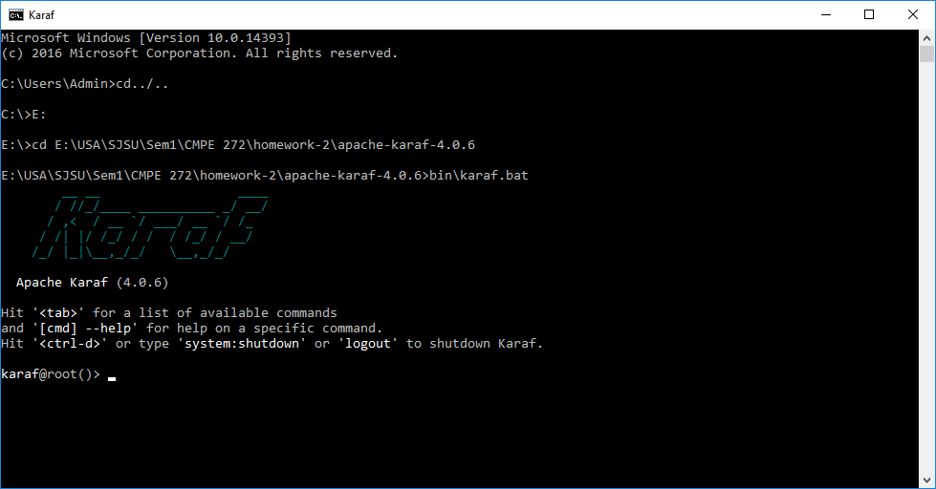

* 1. Download the sample project from <https://github.com/cschneider/Karaf-Tutorial/zipball/master> and extracting it to a directory.
  2. Importing the downloaded project into eclipse as:
* Open Eclipse IDE, go to Eclipse Package Explorer: Import -> Existing maven project -> Browse to the extracted directory into the task list sub directory.
* It will show all existing maven projects. Then click to import all projects with defaults.

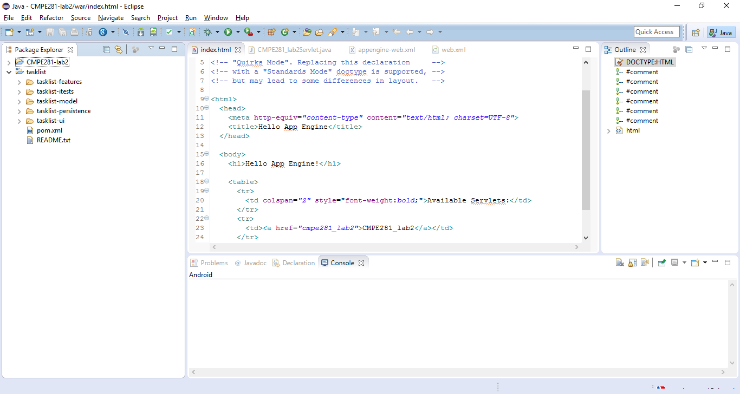

* 1. In Command Prompt run Command : LIST

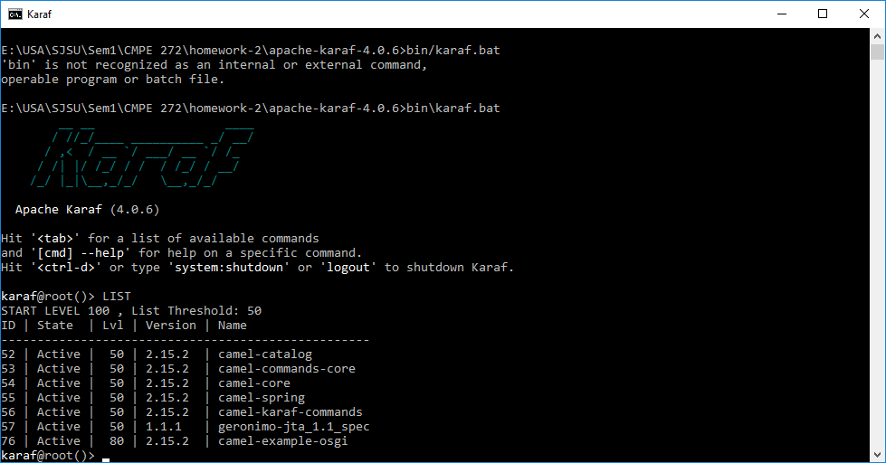

* 1. Now installing the application in karaf by using the following command in karaf command prompt as
* Run: pom.xml file using command prompt.
* Run: mvn install
* Run: feature:repo-add mvn:net.lr.tasklist/tasklist-features/1.0.0-SNAPSHOT/xml
* Run: feature:install example-tasklist-persistence example-tasklist-ui
* It shows everything is successfully installed and run.

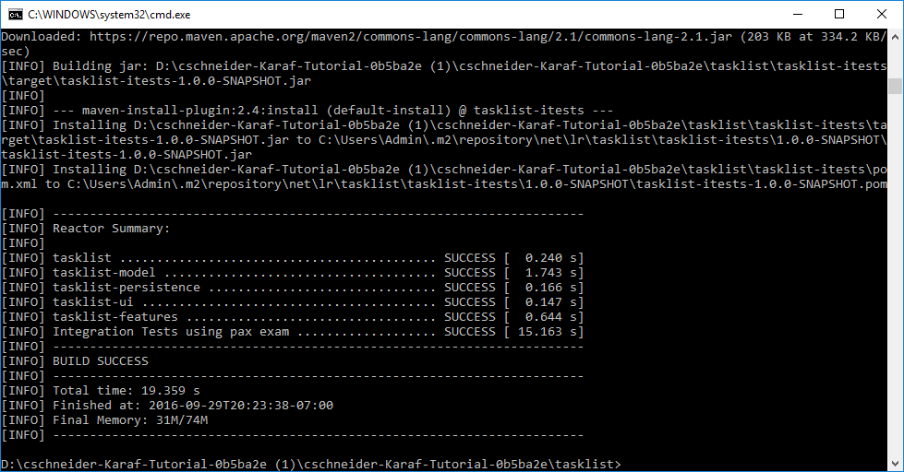

* 1. To view the result, start <http://localhost:8181/tasklist>

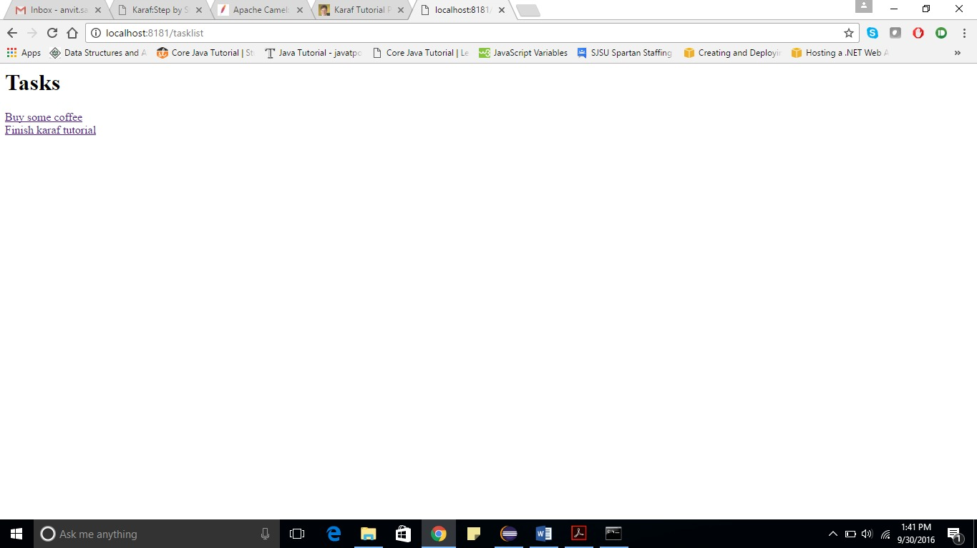

1. **DESIGN:**

*Welcome Screen*

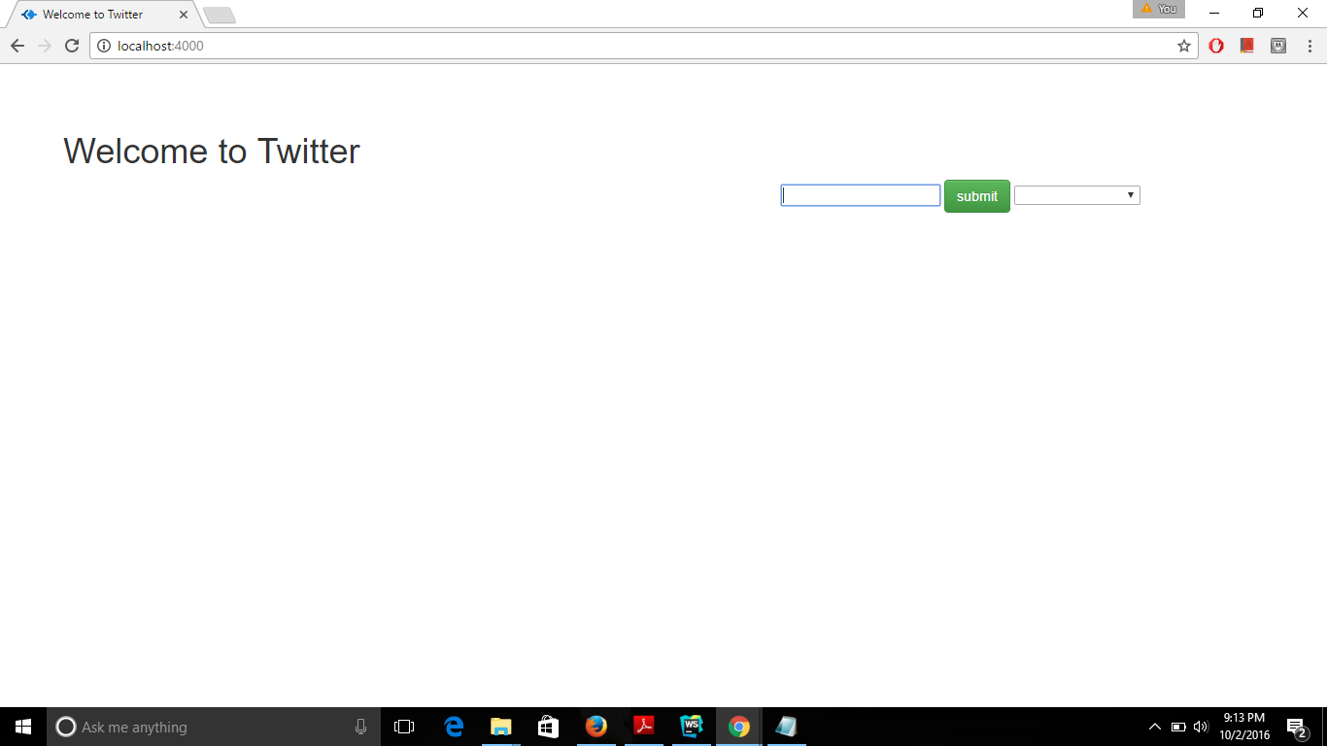

We have implemented 10 Rest APIs from twitter which have been mentioned below.

* GET statuses/user_timeline

# GET statuses/home_timeline

# POST friendships/create

# GET search/tweets

# POST statuses/update

# GET followers/ids

# GET followers/list

# GET users/search

# GET trends/place

# GET friends/list

# 2.1 GET statuses/user_timeline

This API returns the most recent Tweets posted by user.

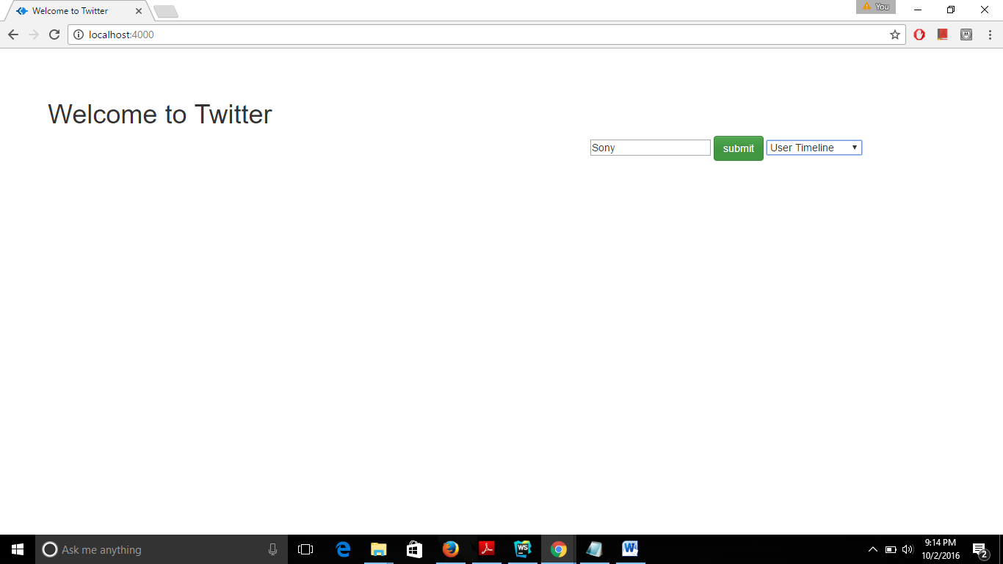

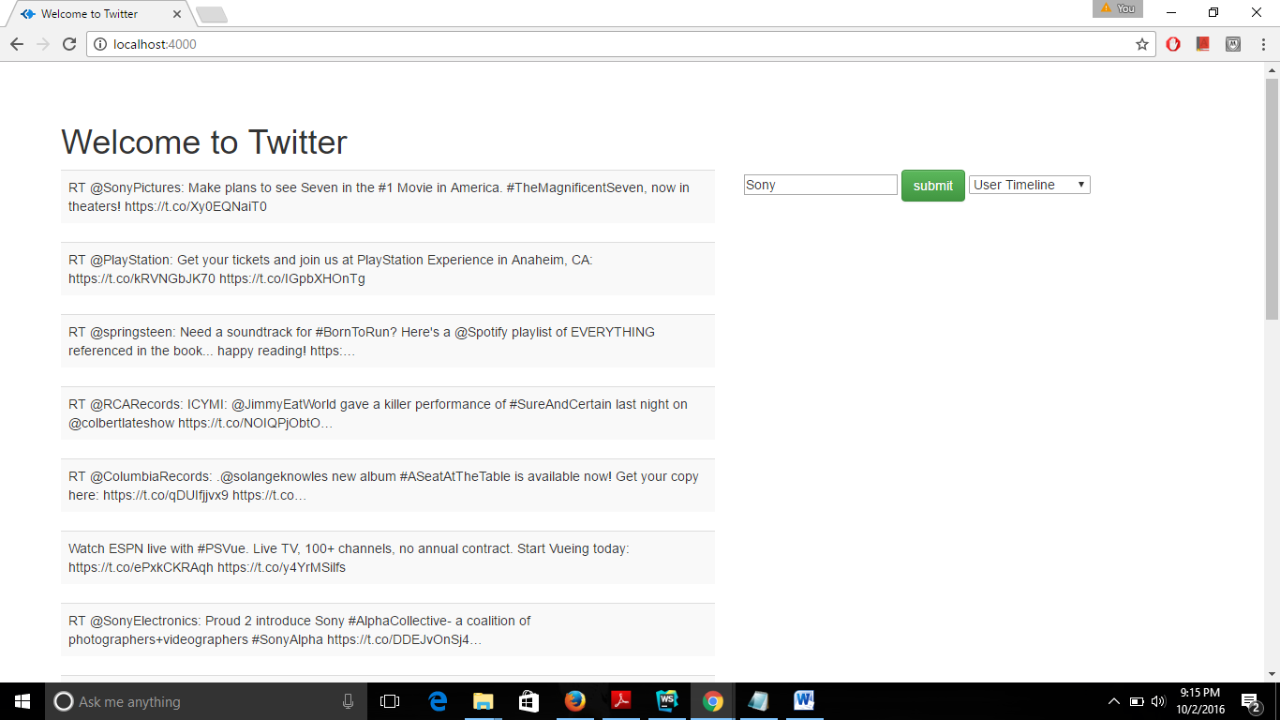

# GET statuses/home_timeline

# This API returns the recent Tweets posted by user and the users they follow.

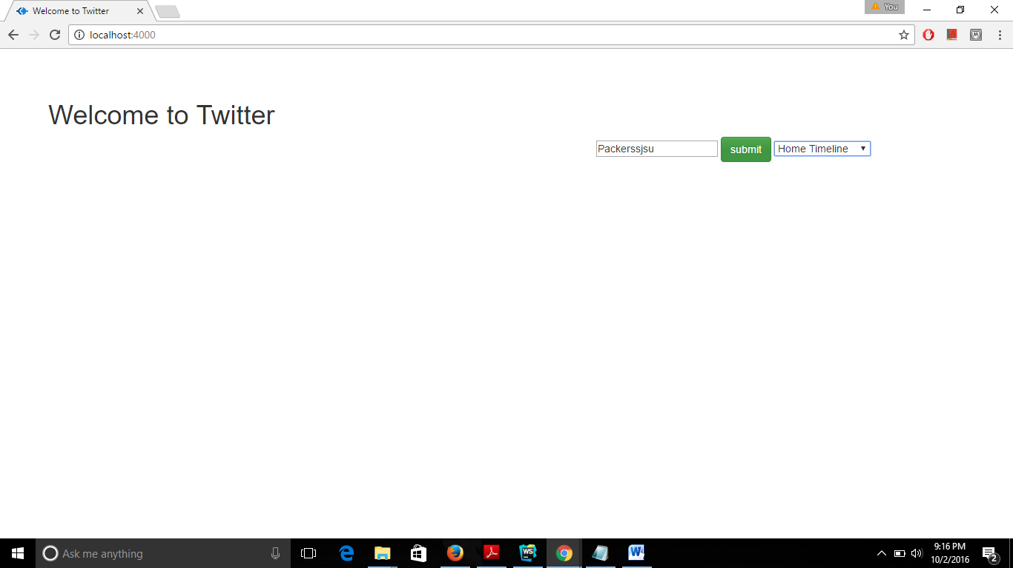

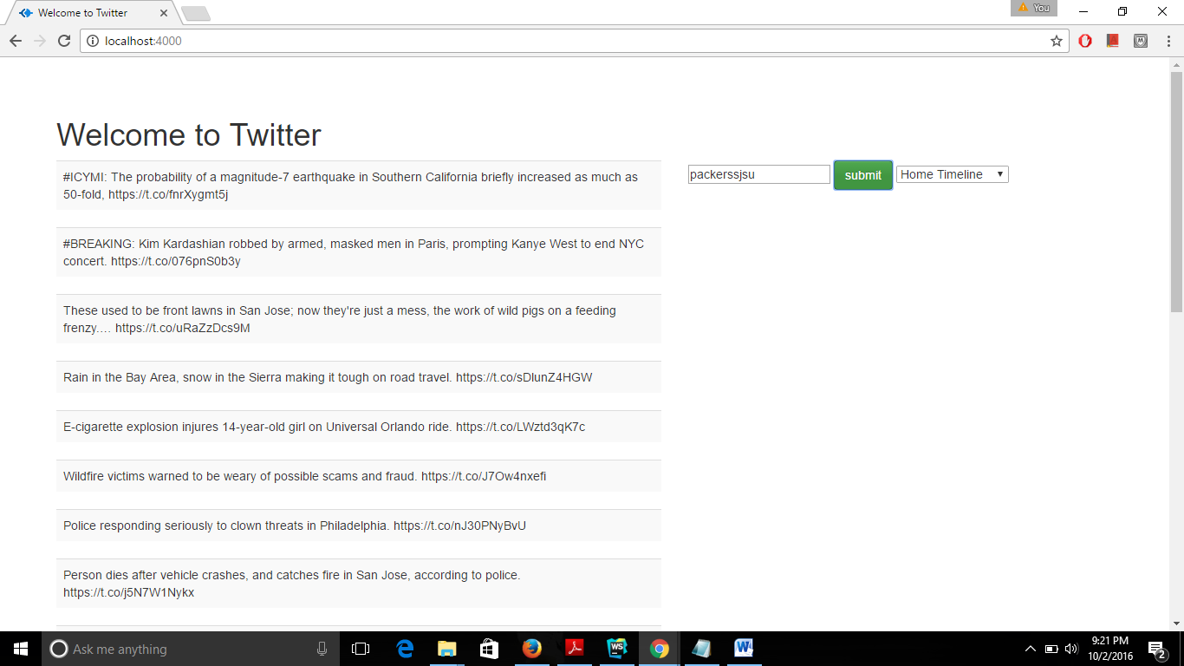

# 2.3 POST friendships/create

This API is to follow your friends on Twitter.

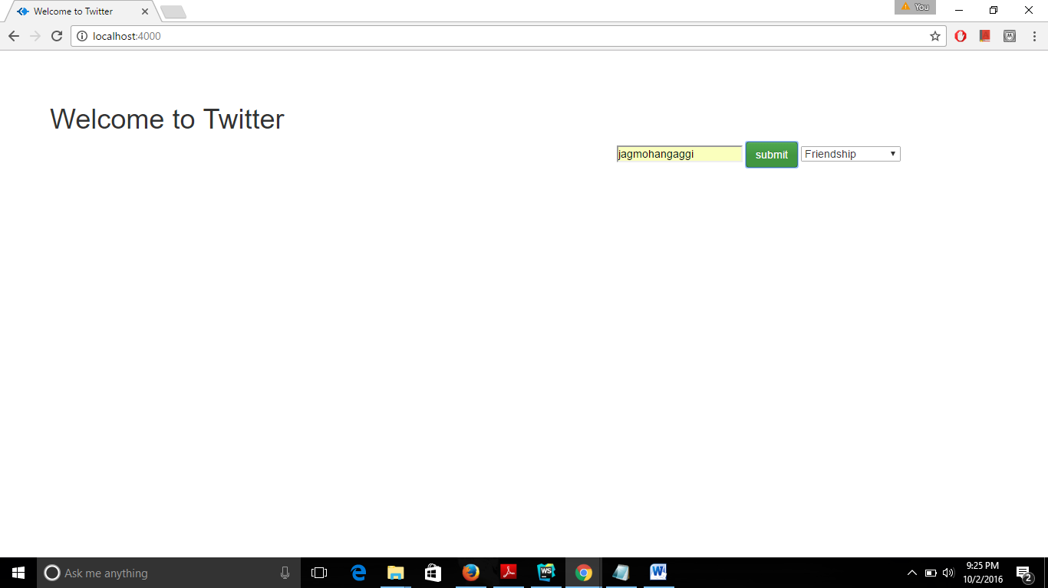

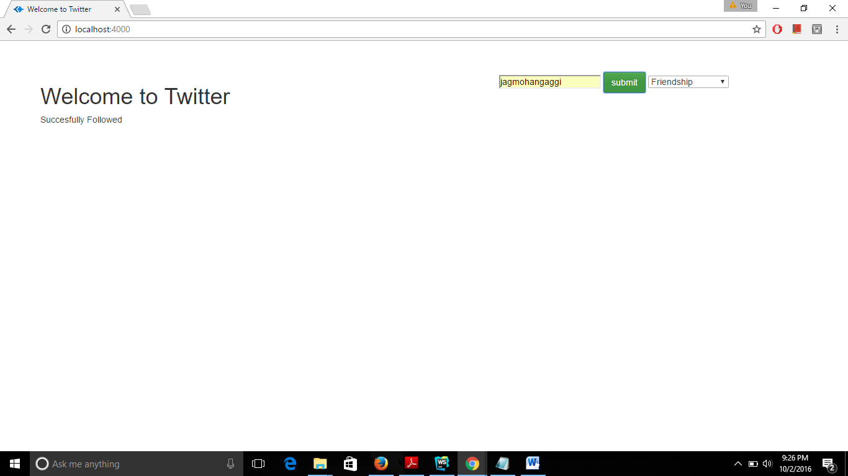

# 2.4 GET search/tweets

# This API returns Tweets related to query specified.

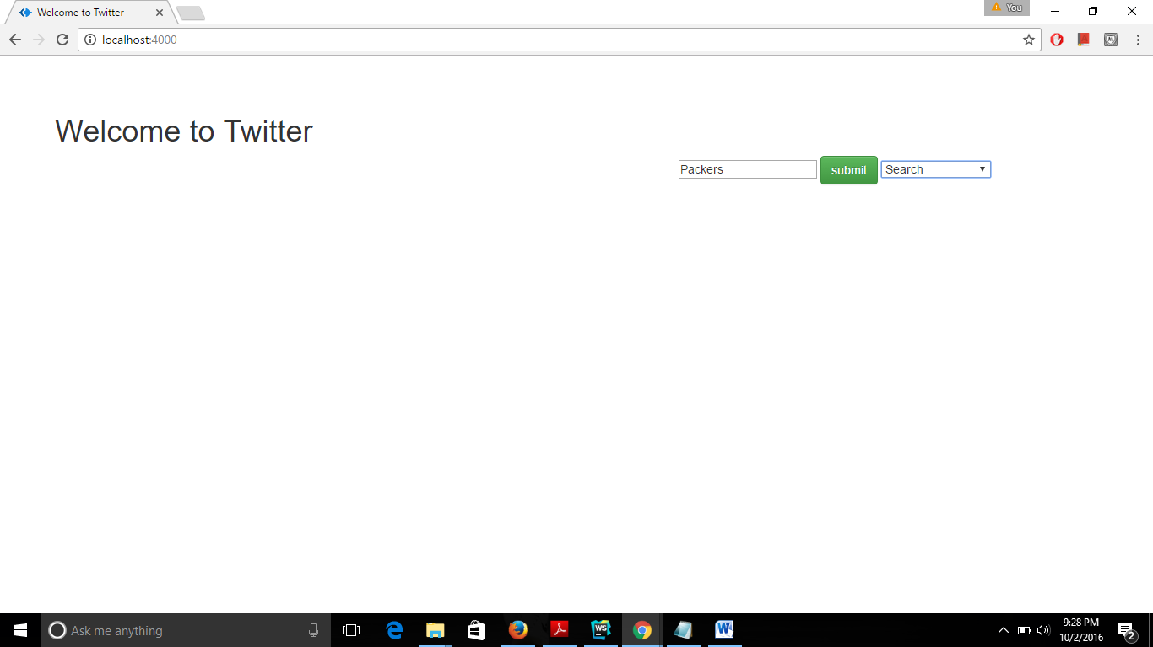

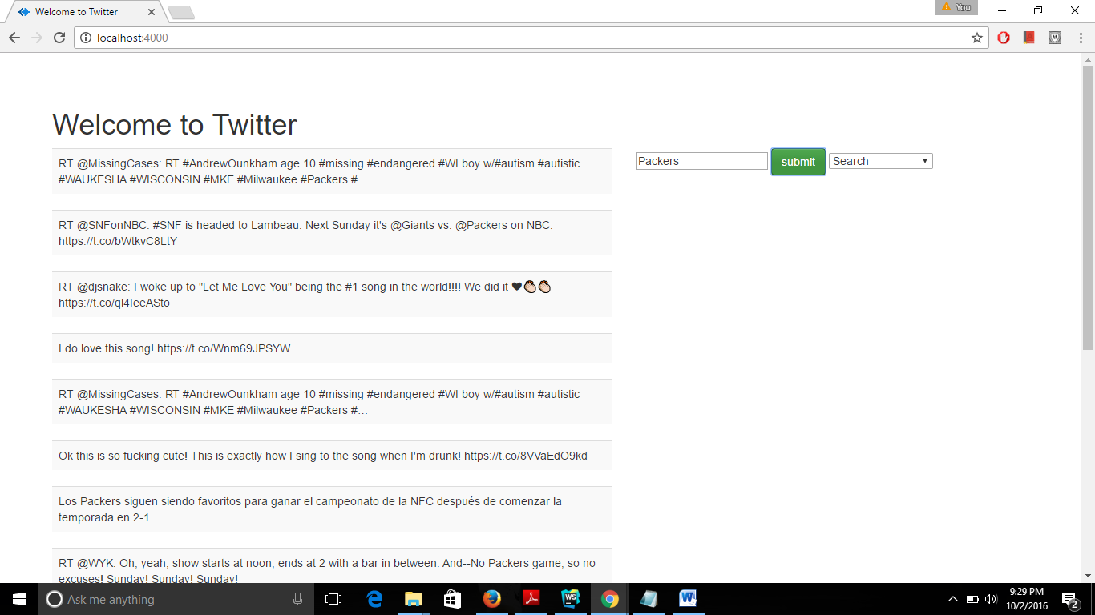

* 1. **POST statuses/update**-

This API is used to update the status of User.

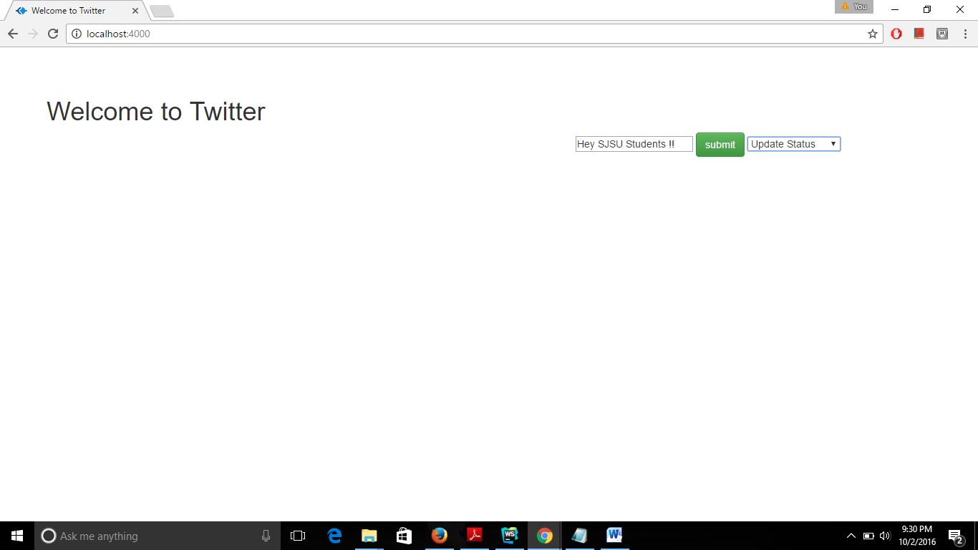

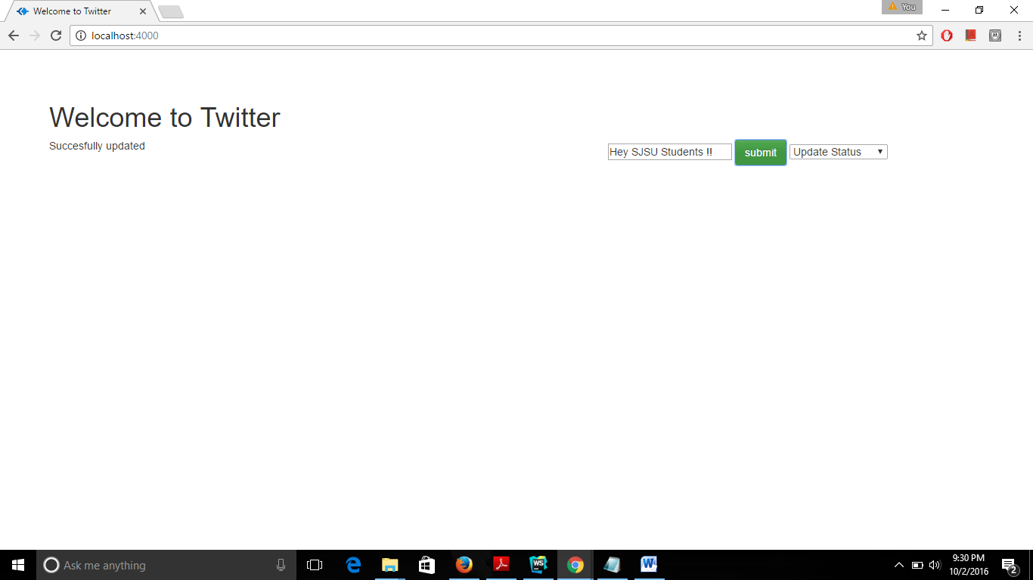

* 1. **GET followers/ids** –

This API returns user IDs of every user following the specified user.

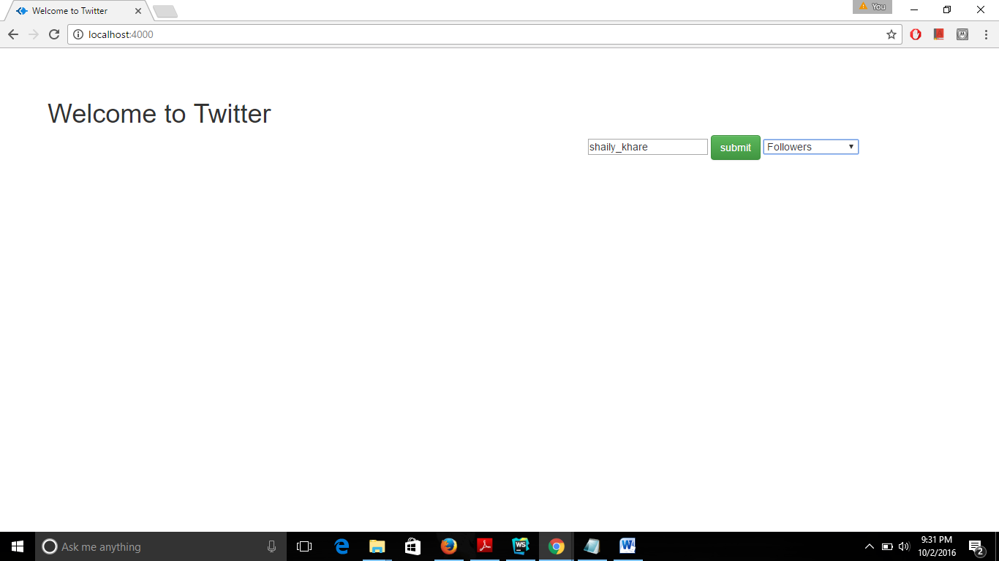

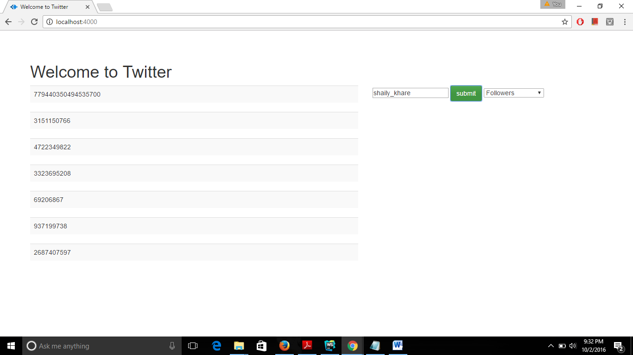

* 1. **GET followers/list** –

This API returns user objects of users following the specified user.

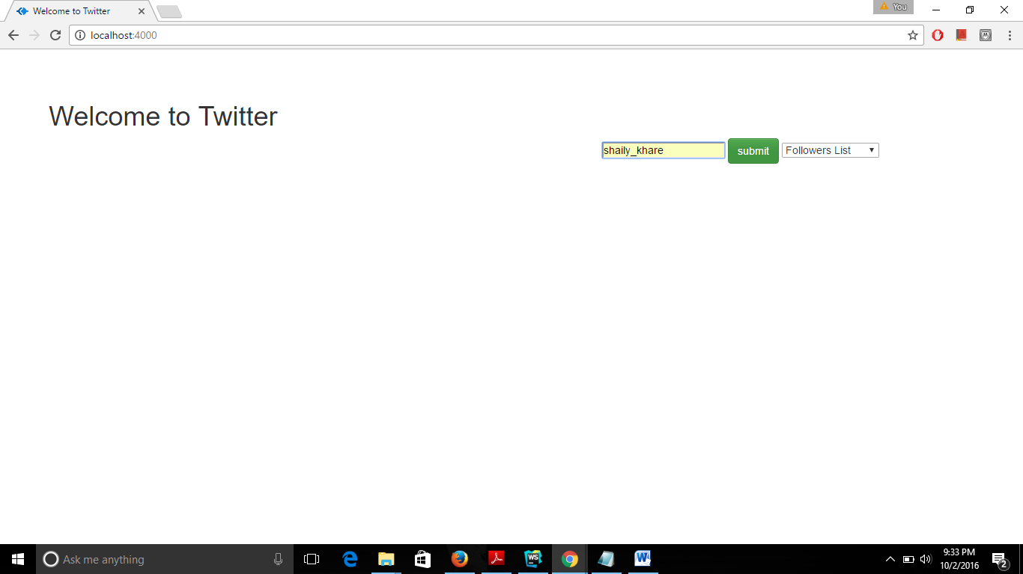

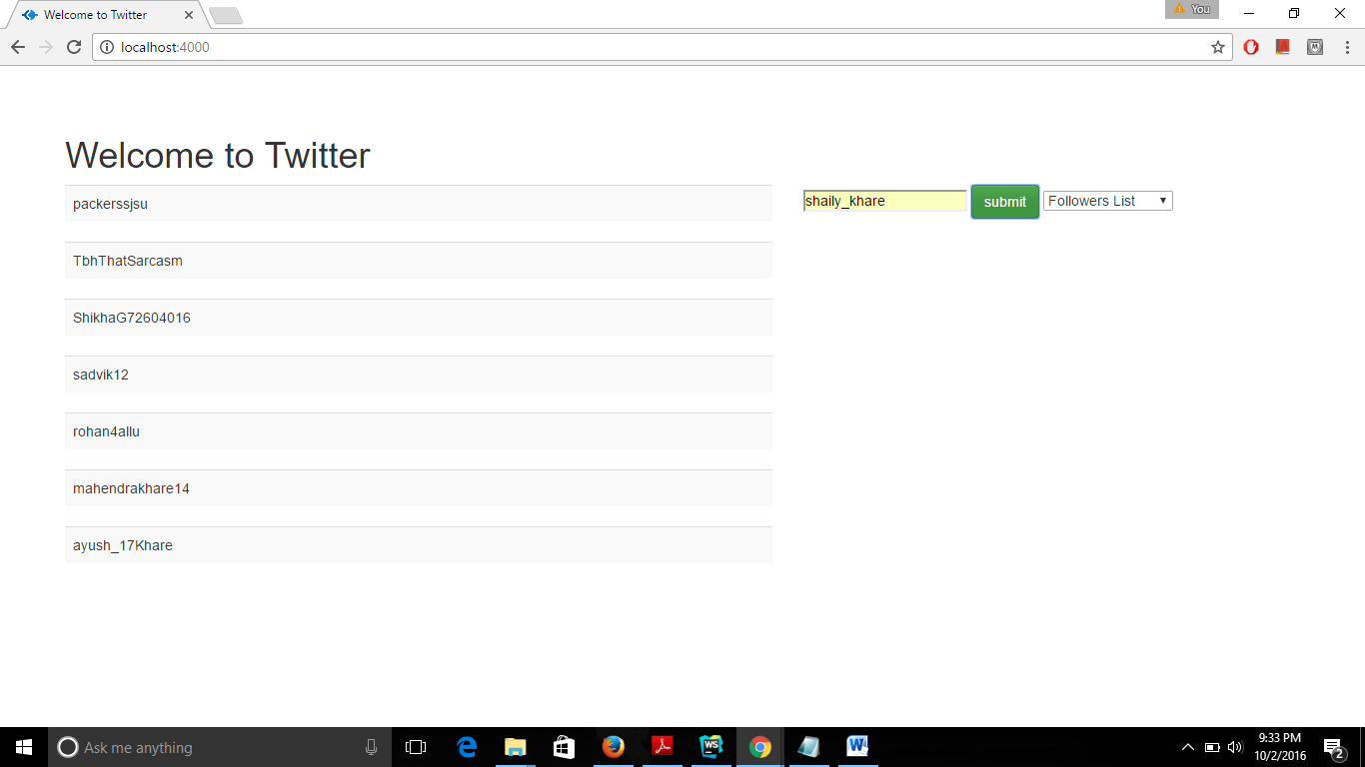

* 1. **GET users/search** –

This API gives a simple, related search interface to public user accounts on Twitter.

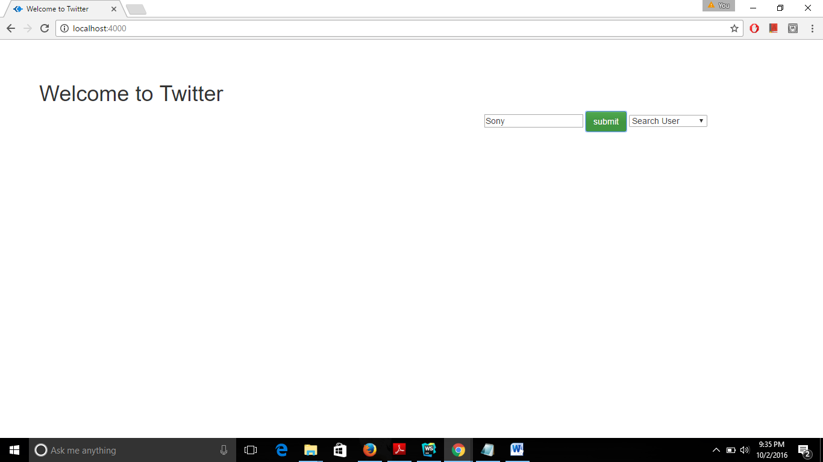

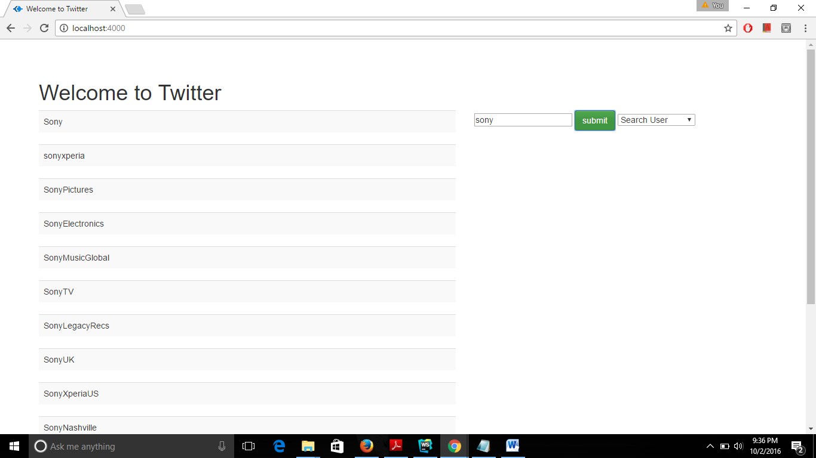

* 1. **GET trends/place** -

This API returns trending topics for a specific WOEID.

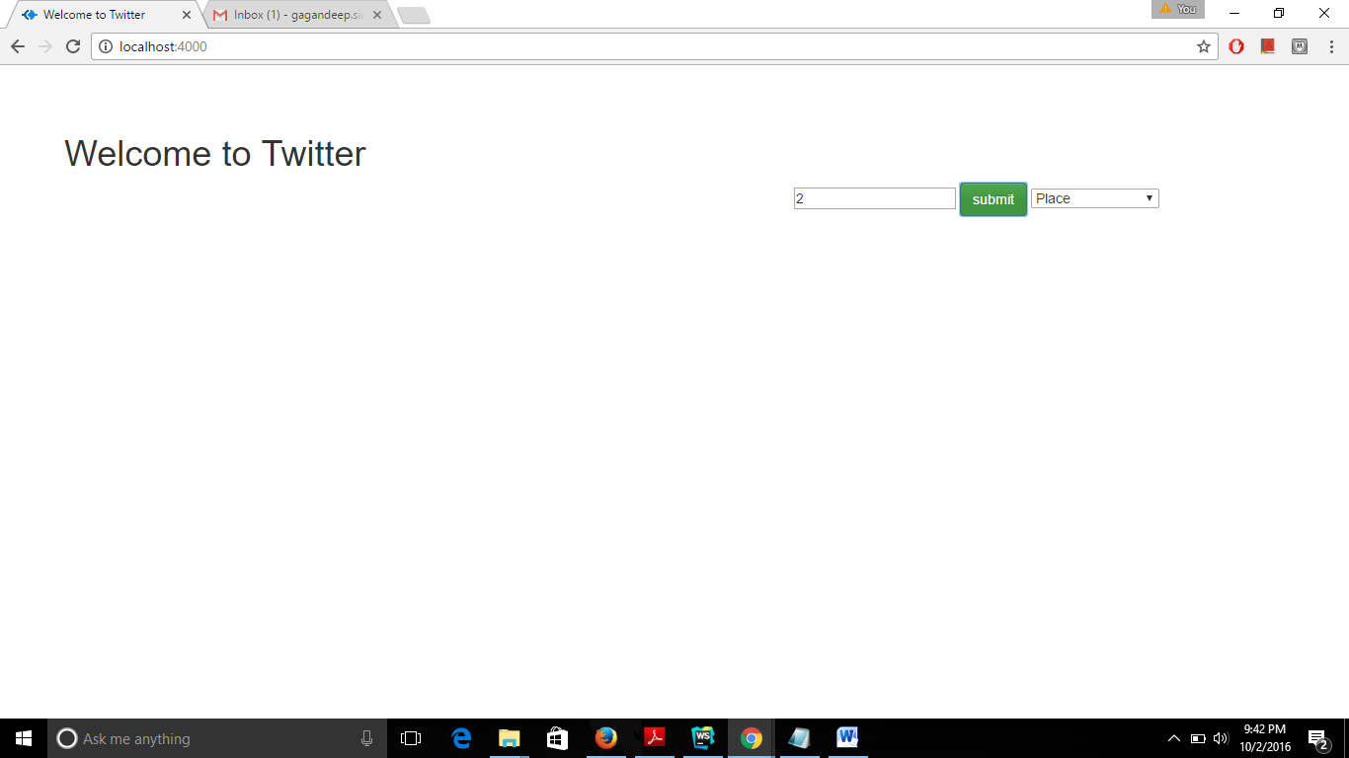

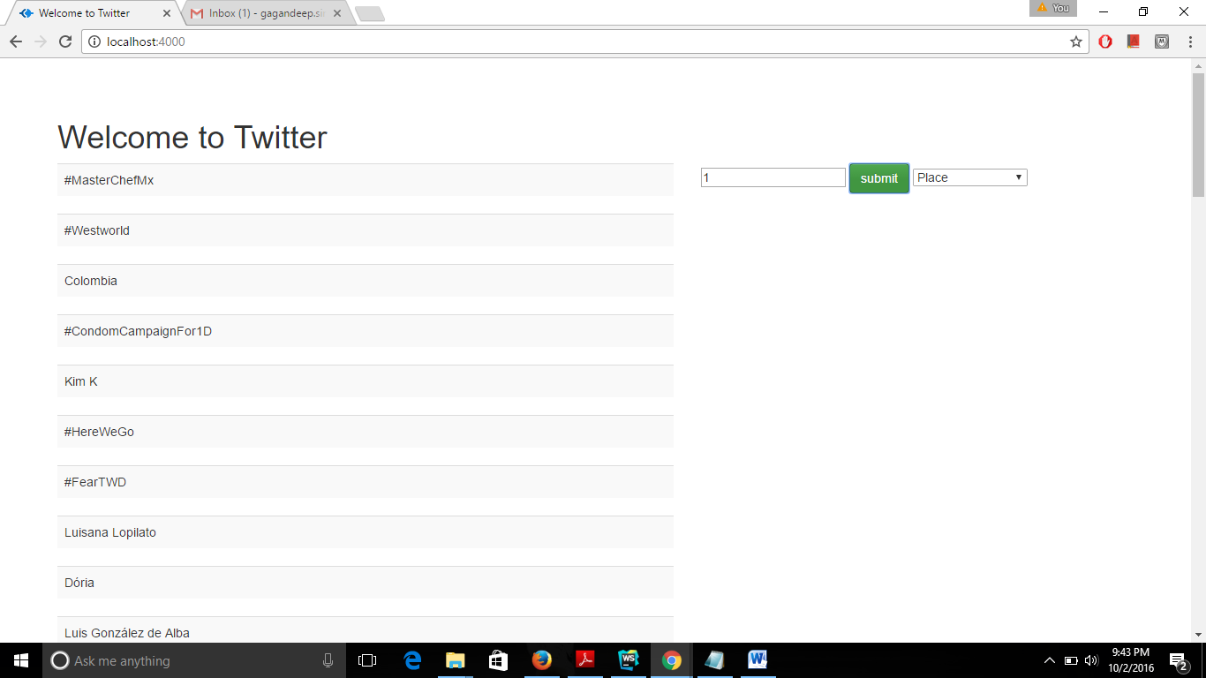

* 1. **GET friends/list** –

This API returns user objects for every user the specified user is following.

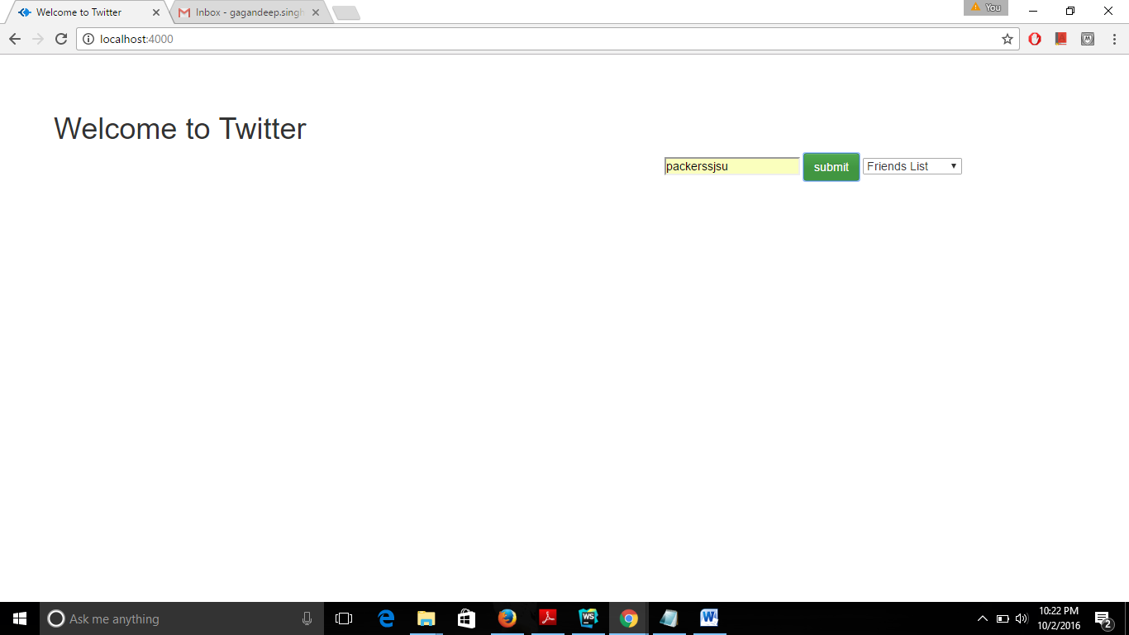

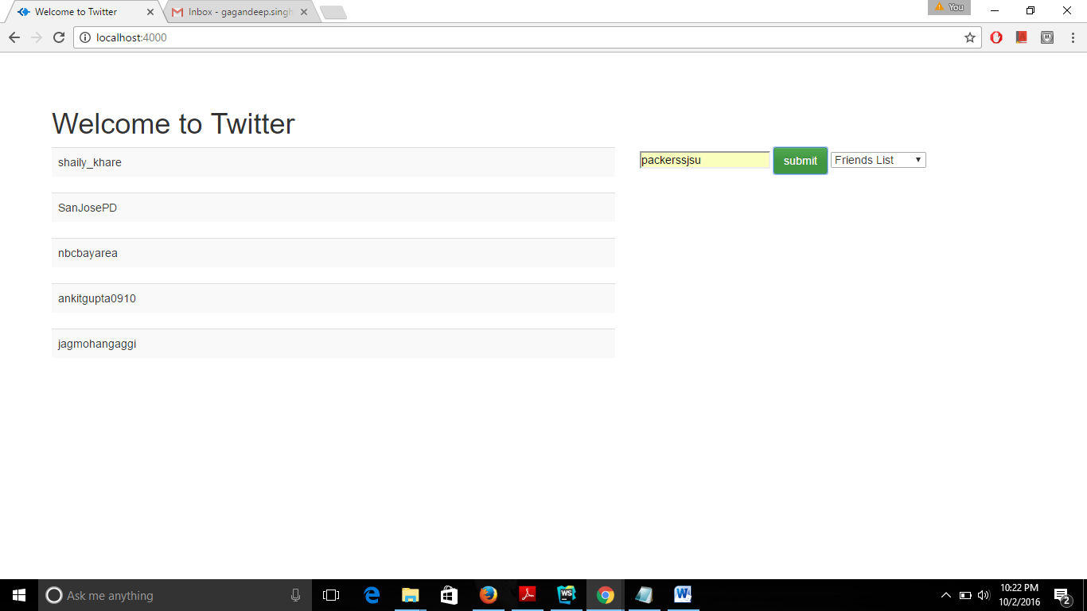

1. **UML DIAGRAMS**
   1. Use Case Diagram

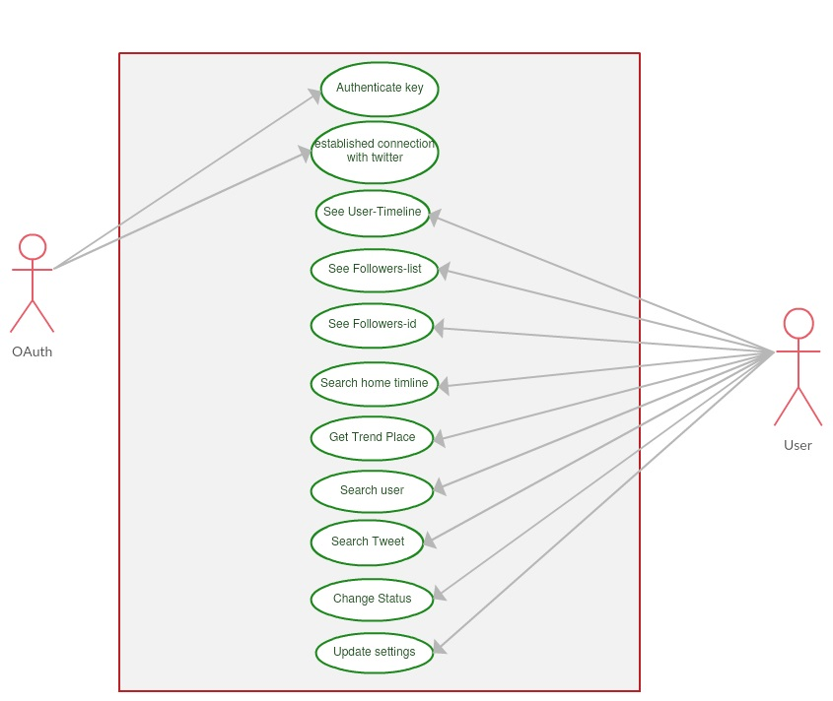

3.2 Sequence Diagram

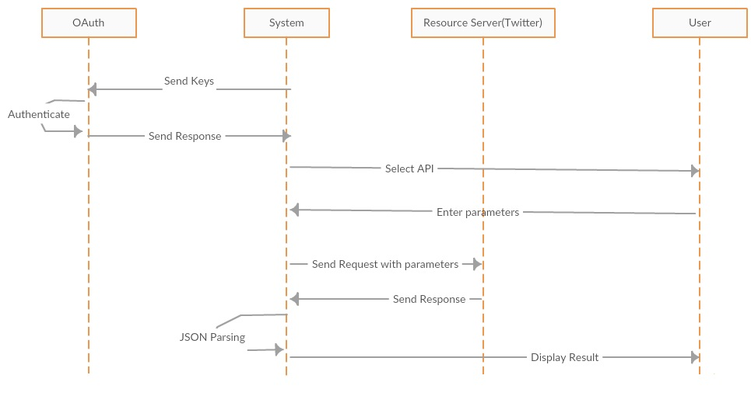

1. **TESTING UNIT**

Steps for Testing:

1. Install testing unit *Chai Mocha* using the command as: npm install chai mocha. Also importing package.json using npm command which will help in installation of the required node modules.
2. Create a file name test.js in Karaf Project where ‘Karaf’ is project folder’s name.
3. Run the file with the command mocha test.js

Below is the screenshot where we run the test and all the tests pass successfully.



Below is the screenshot with one test fail (Update Status).

